Task 1: Characters used for regex.

(.): Used to match a single character.

(*): Matched preceding elements zero or more times.

(+): Matches preceding elements one or more times.

(?): Matches the preceding element zero or one time.

(^): Matches the beginning of a string or line.

($): Matches the end of a string or line.

[]: Defines a character set. Matches any single character within the brackets.

(): Groups parts of the regex and can be used for capturing matched text.

\: Escapes a metacharacter to treat it literally or introduces special sequences.

Task 2:

Linux is an open-source OS Kernel known for being versatile across variety of hardware. It mainly supports multitasking and multi-user environments. It has a powerful CLI and offers high control, customizability and since its an open-source OS, it also has a good community support.

Task 3:

Kernel is a component of the computer that acts as a bridge between applications and the computers hardware. Put in simple words, it can be compared to project manager where employees can be compared to the applications and the company’s resources can be compared to the system hardware.

Task 4:

BASH refers to Bourne-Again Shell

It is an upgraded version of the original Bourne shell with additional features like command history, tab completion and scripting capabilities.

Task 5:

* Linux is free and open source whereas windows is a paid OS.
* Linux is highly secure whereas windows is less secure compared to windows.
* Linux is more efficient than windows.
* Linux file systems are case sensitive whereas in windows, they are not.

Task 6:

Basic components of Linux

Kernel: A bridge between software and hardware.

Shell: Shell is the interface between user and kernel that lets user to interact with the computer.

GUI: Graphical user interface, which is also another way for the user to interact with the computer.

Applications: Applications installed in the system

System Utilities: In built software functions through which users can manage the system.

Task 7:

Kernel modifications are legal as long as the modifications are licensed under GPLv2 Obligations.

Kernel can be modified to support unconventional hardware or improve the existing hardware support.

Also done for performance tuning and to have enhanced security.

Task 8:

LILO also known as LInux Loader used to be a popular bootloader for Linux in the early days. It is now replaced by GRUB. (GRand Unified Bootloader).

Task 9:

A shell is a user interface that allows you to interact with the operating system's kernel.

**Bourne Shell (sh):**

* Original UNIX shell.
* Base model for several other shells.
* Found as /bin/sh on UNIX like systems.

**C Shell(csh):**

* Introduced new features like command history aliases and job control.
* Syntax resembles C programming language.

**TC Shell(tcsh):**

* Advanced version of C shell.
* Provides features like command-line completion, more sophisticated job control, and better history management.

**Korn Shell(ksh):**

* Combination of best features from Bourne shell and C shell.
* Introduced features like command-line editing, job control improvements, and functions.

**Bourne-Again SHell (BASH):**

* The most common default shell on most Linux distributions and also available on macOS.
* Backward-compatible with the Bourne shell.
* Includes many powerful features like command-line completion, extensive scripting capabilities, command history, aliases, functions, and more.

**Z Shell (zsh):**

* An extended Bourne shell with many improvements and features beyond Bash.
* Known for its powerful auto-completion, theming capabilities, and extensive plugin system (e.g., Oh My Zsh).
* Gaining popularity as a default shell on some systems (e.g., macOS since Catalina).

**Friendly Interactive Shell (fish):**

* Focuses on user-friendliness and discoverability.
* Features include autosuggestions, tab completions that display options, and a simplified scripting syntax (not fully POSIX-compliant).

Task 10:

Swap Space: A dedicated area on the hard drive which Linux can utilize as a Virtual RAM when the physical RAM is full. It makes multitasking more feasible in Linux.

Task 11:

Mounting refers to attaching a new branch of storage system to the root storage making the mounter storage accessible as well.

Mounting: sudo mount [options] <device> <mount_point>

Unmount: sudo umount <device> or sudo umount <mount_point>

Task 12:

chmod stands for change mode. It is used to modify access permissions of files and directories (rwx)

for owner(u), group(g) and other(o) users.

* chmod u=rwx,g=rx,o=r my_program

using octal values: 4-read, 2-write, 1-execute, 0-no permission.

Chmod 754 file.exe

Task 13:

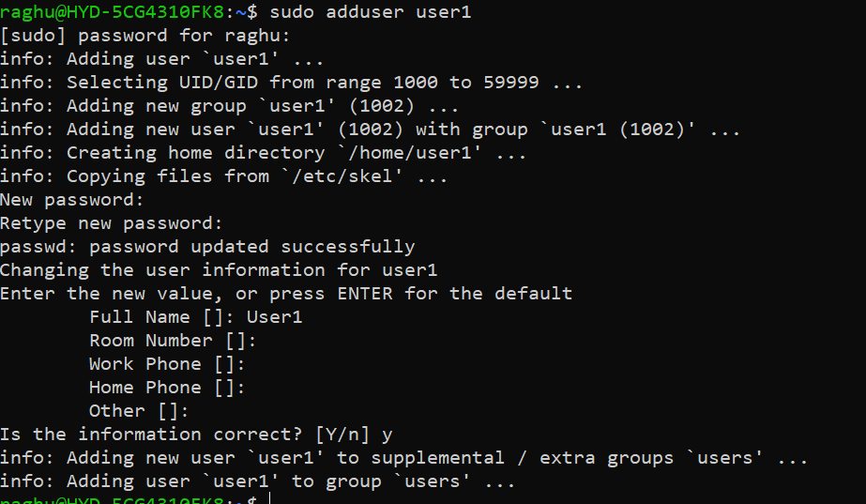

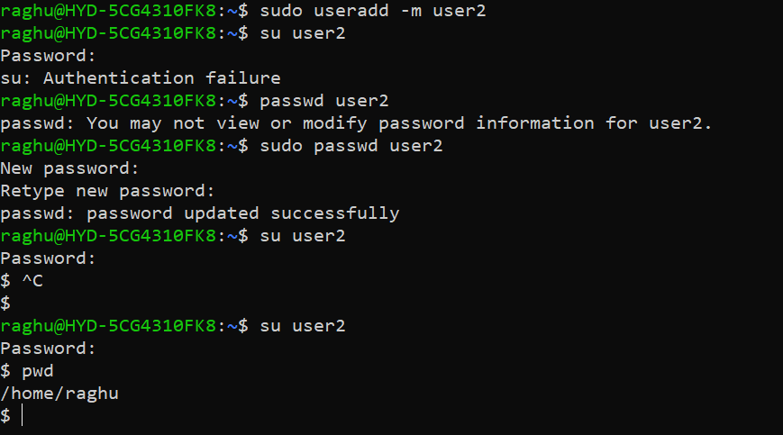

Task 14:

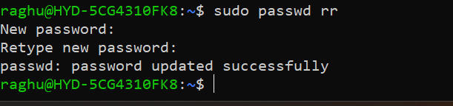

Task 15:

A process can be defined as a running instance of a program. When we launch an application, the OS creates a process to run the application.

A thread on the other hand is a unit of execution within the process. A process can contain multiple threads execution concurrently.

Task 16:

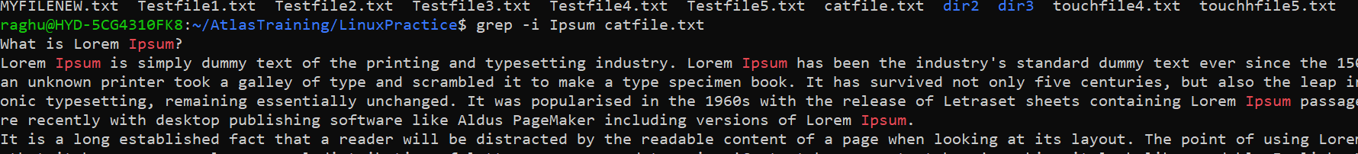

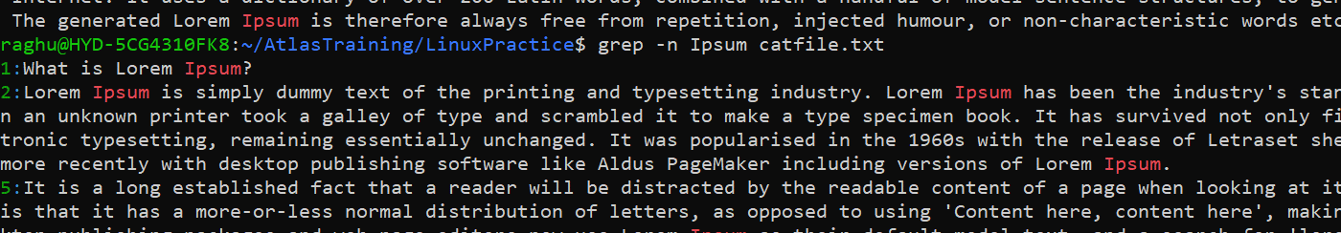

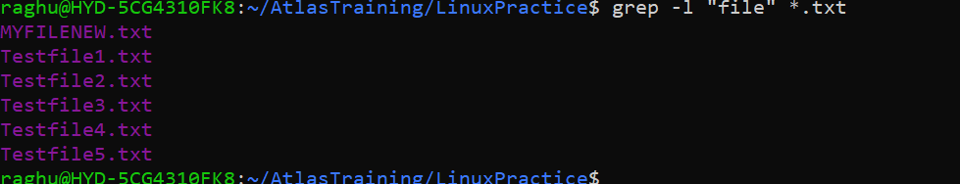

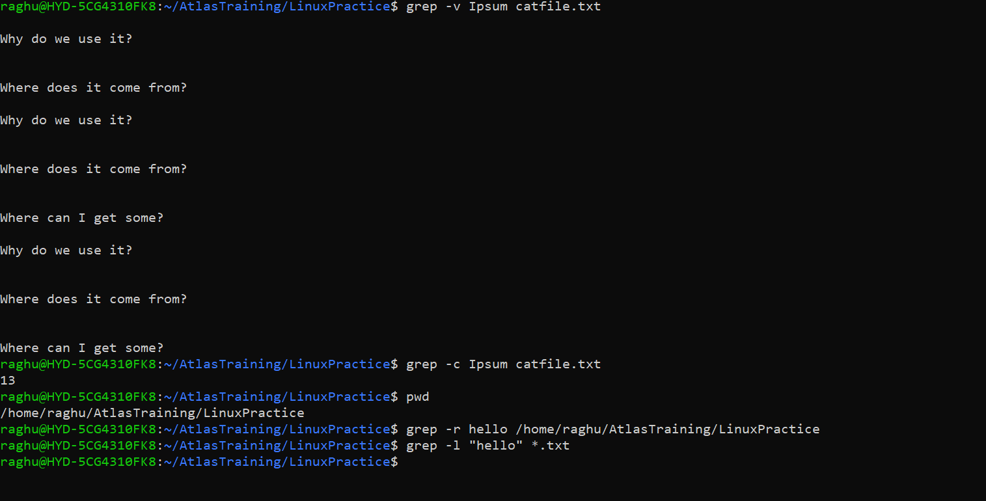

Task 17:

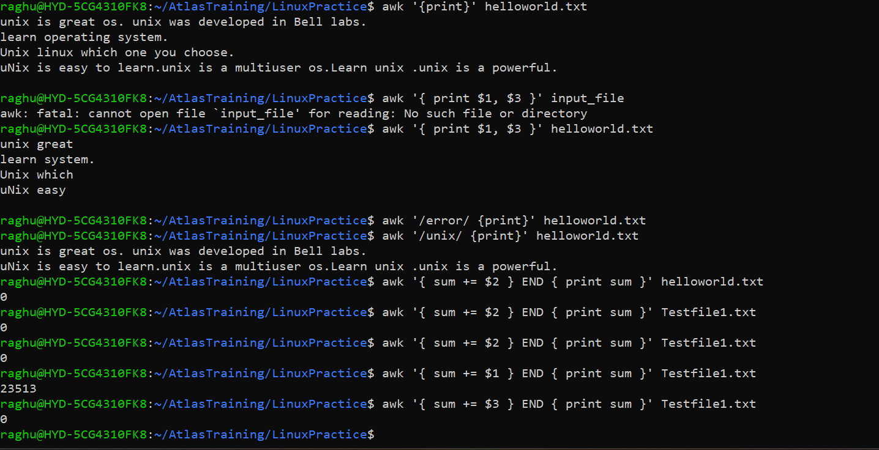

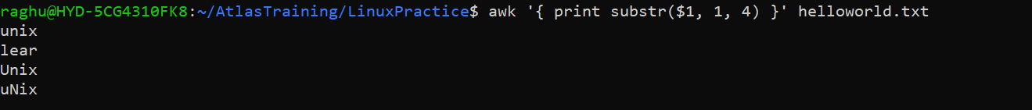

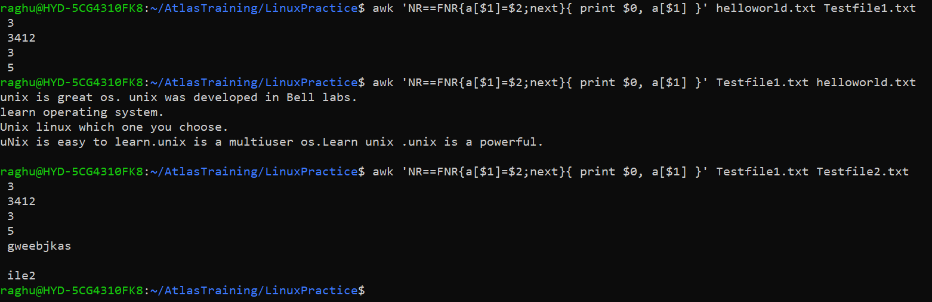

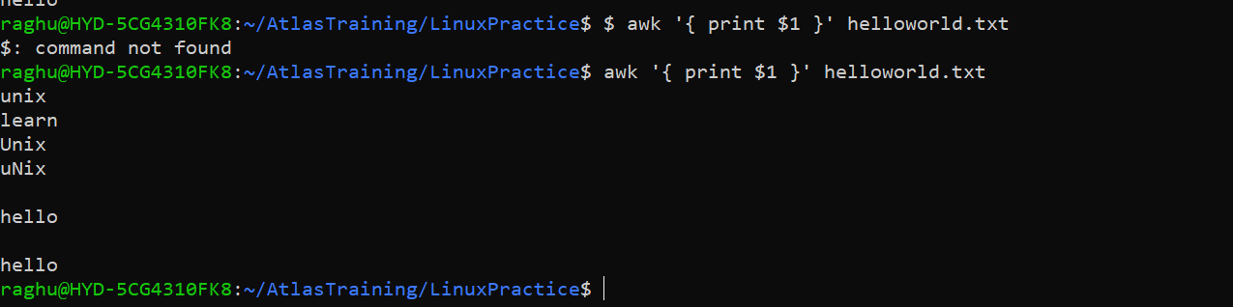



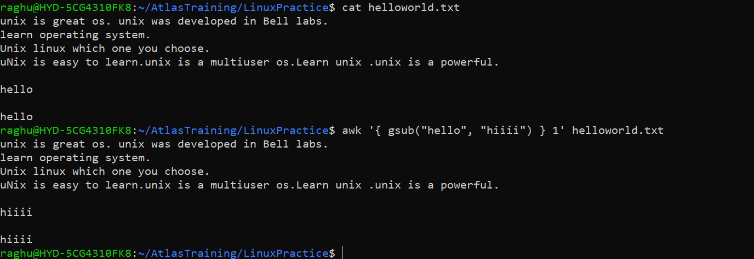

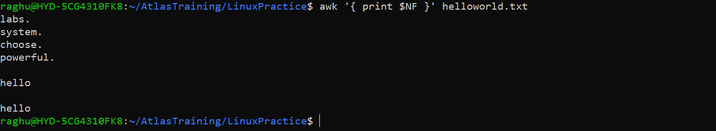





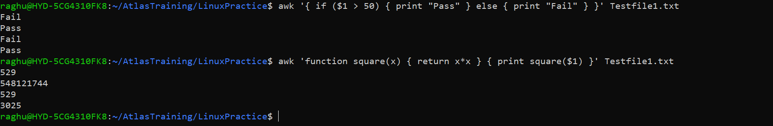

Mk link and rm link

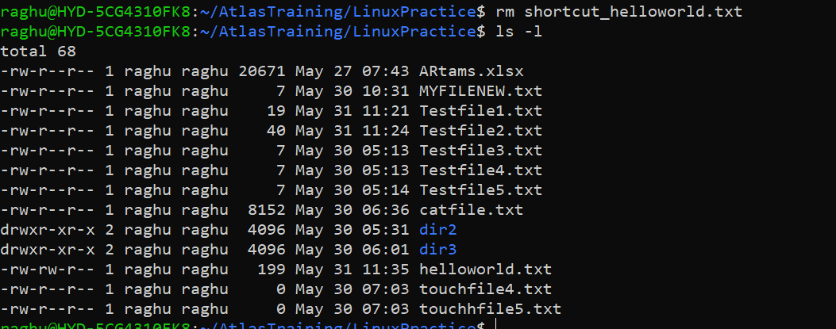

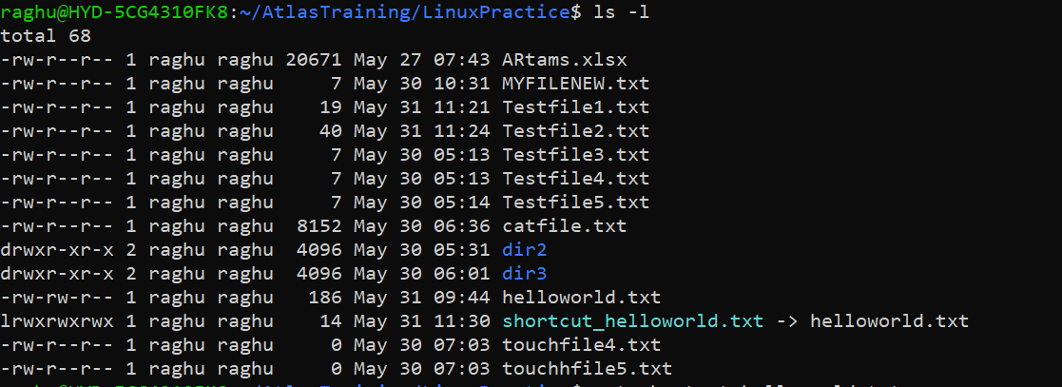

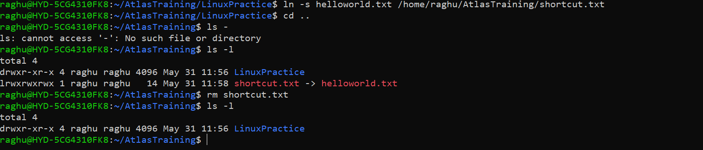

Task 18:

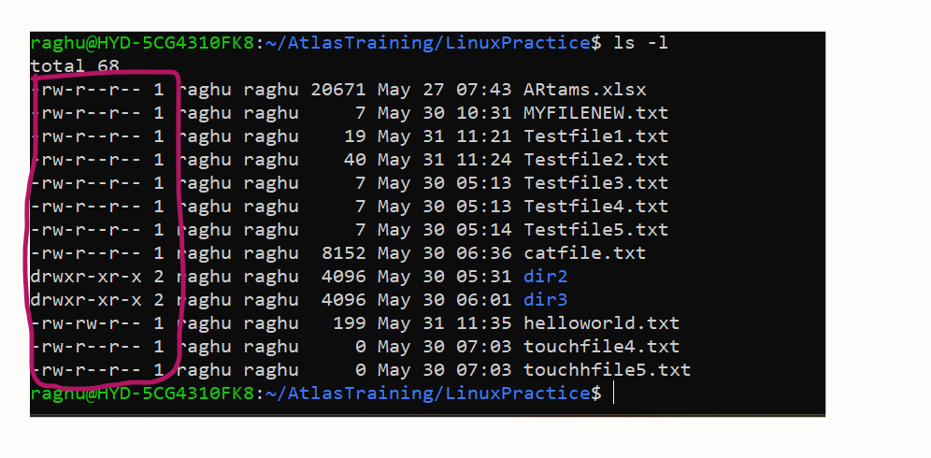

Owner-group-all&others

r- read, w- write, x-execute

Task 19:

Owner: rw

Group: rw

All and others: r

Task 20:





Task 21:





Task 22:





Task 23 & 24:

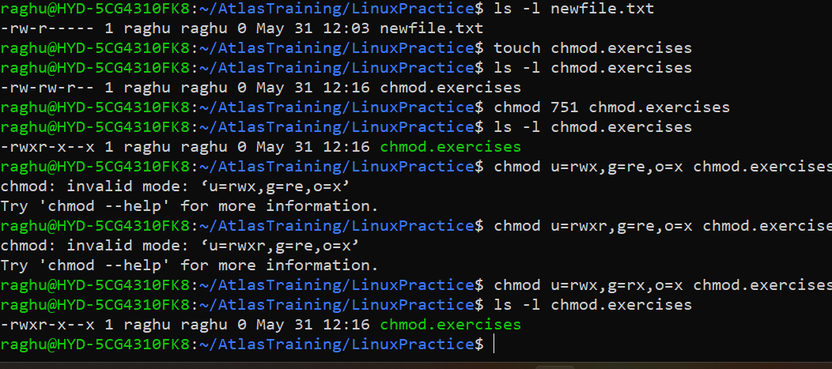

Task 25:

Change ownership of a file.

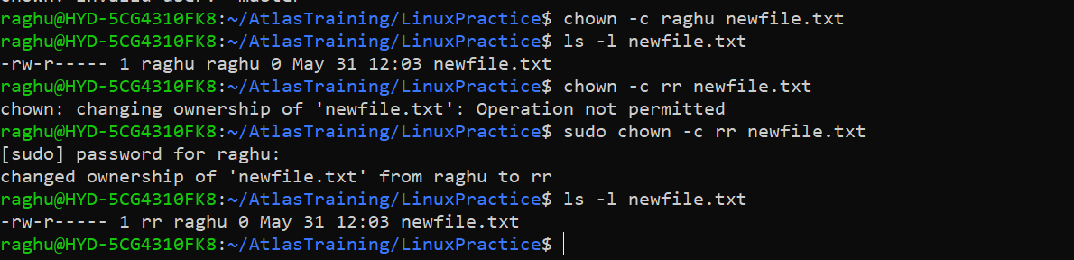

Task 26:

A process is running instance of a program within its own memory space, resources, and execution context.

Task 27 & 28: ps and ps aux for foreground and running processes and jobs for background processes

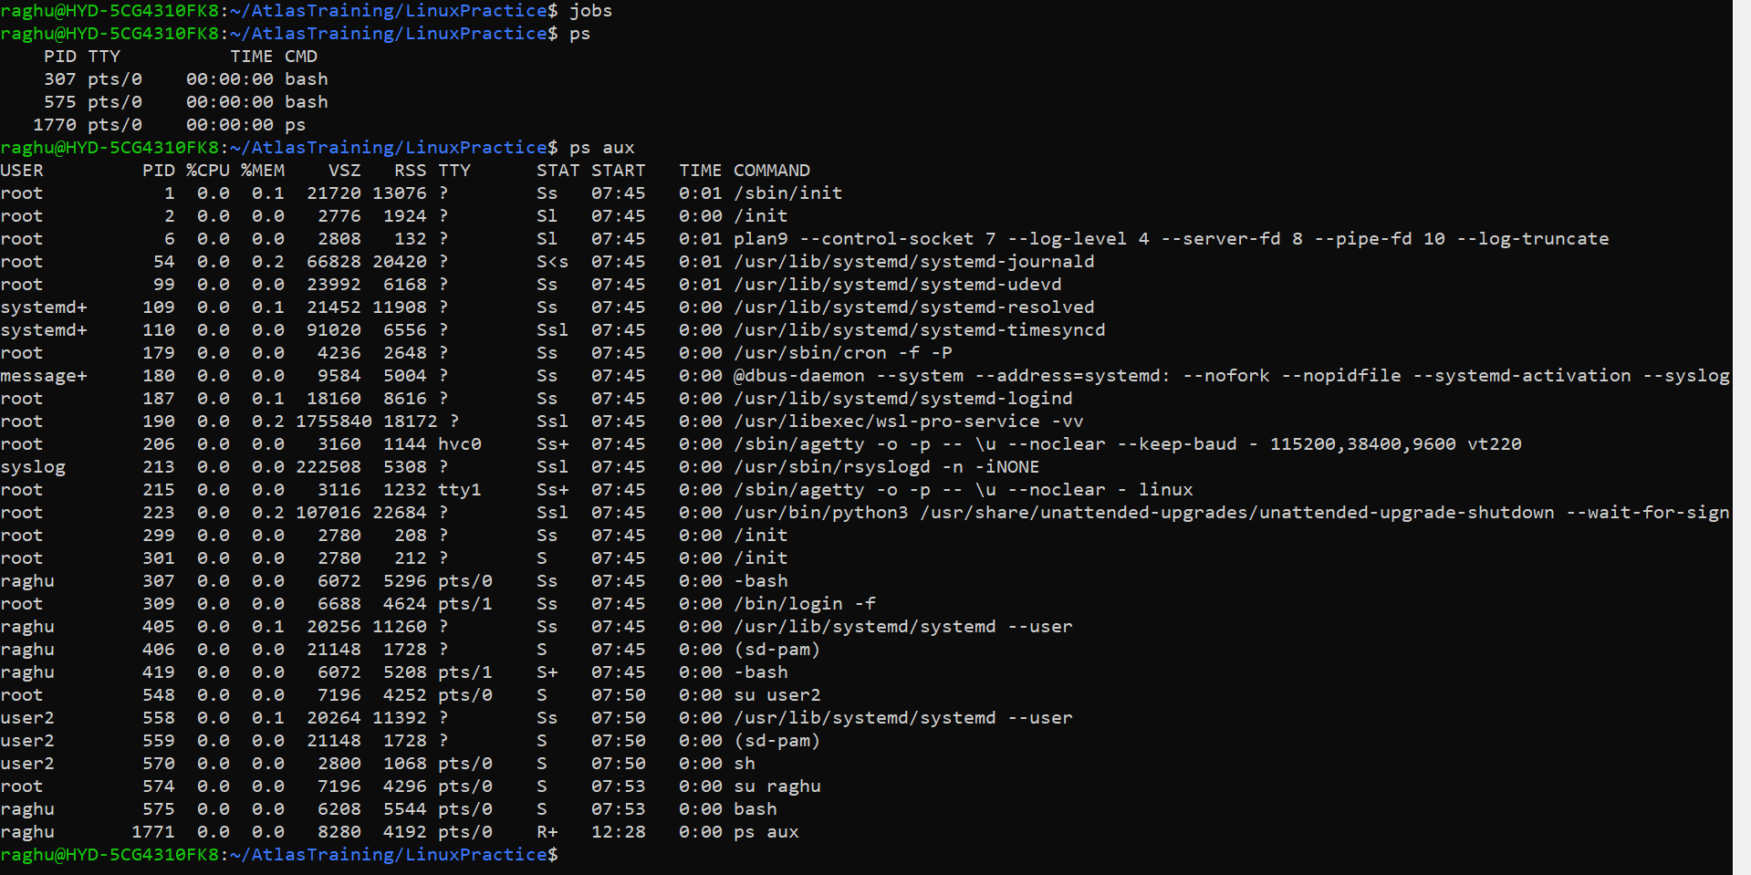

Task 29:

Ps -f : displays information about currently running processes.

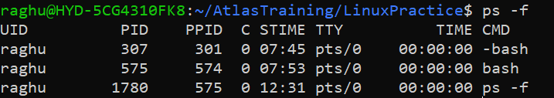

Task 30:

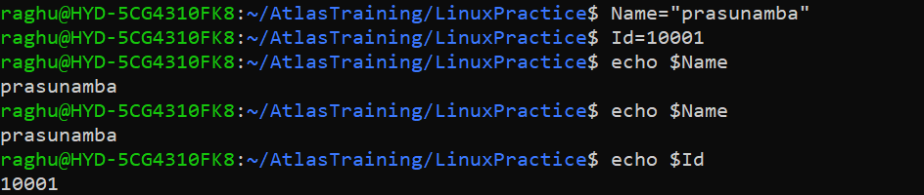

Task 31:

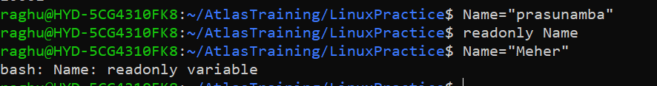

Task 32:

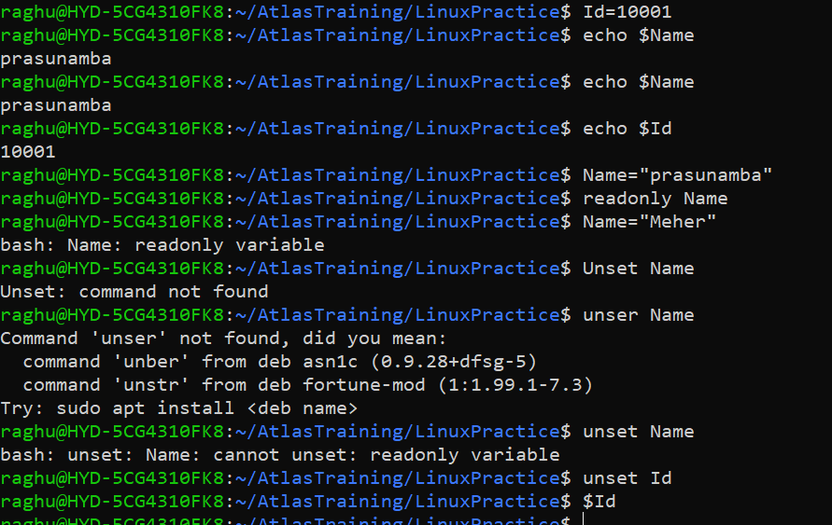

Task 33, 34:

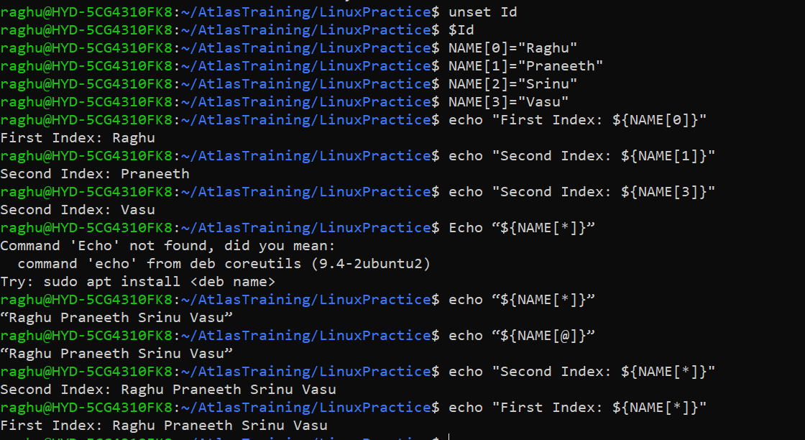

Contd.

Task 35:

